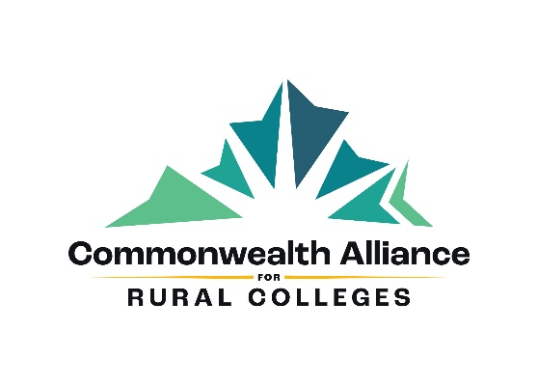

Strategic Plan

March 30, 2021


Facilitated by

Table of Contents

Item Page Number

Executive Summary 2

Engagement and Process 3

The Commonwealth Alliance for Rural Colleges 4

Observations, Analysis, and Conclusions 9

Recommendations and Timeline 17

Attachment 1 – Interview Participants 25

Attachment 2 – Interview Questionnaire 26

Attachment 3 – Bibliography and References 27

Executive Summary

Warner & Associates Consulting acknowledges and appreciates the unmitigated support received from staff, board members, and donors facilitating the Commonwealth Alliance for Rural Colleges’ (CARC), formerly the Virginia College Fund, next strategic plan. All clearly believe the CARC continues to play an important role for its six member institutions and the Commonwealth of Virginia’s comprehensive higher education system. It provides visibility and access to constituencies with whom the colleges may not otherwise connect. Additionally, the six colleges and their respective presidents are highly regarded. There is a clear need in the commonwealth for these six providing access to a four-year degree for its “under-represented” population – minorities, first-generation, low-moderate income demographics.

And yet the CARC has struggled to raise the funds supporting the six colleges. As a member organization, the CARC provides financial value to its members by raising contributions exceeding the levies incurred to fund its operations. Its 2016 strategic plan had set out to answer whether the CARC was still relevant after almost 50 years in existence and sustainable. The consensus was a resounding yes to both questions. Subsequently, the consensus agreed to a plan increasing contributions to provide a Return on Investment of 4 to 1 by fiscal year end 2020. Unfortunately, contributions have continued to decline.

Several factors, such as lack of general awareness and general fundraising competition among others, attributed to the lackluster results. However, with a new, energetic, and connected president in place providing innovative ideas and a renewed optimism among the board of directors, the CARC is poised for continued success.

The following recommendations are detailed within the report:
*A red check (✓) indicates that recommendation has been completed since the strategic plan was adopted in March 2021.

- Recommit to a fundraising goal meeting a 4 to 1 Return on Investment to the member institutions.

  - Change the name to better reflect CARC’s mission. ✓

- Invite additional institutions for membership. ✓

- Consider initiating unique programs. ✓

- Adhere to a recommended development plan, to be updated and modified as needed. ✓

- Lay the groundwork to allow endowment contributions. ✓

Engagement and Process

The Commonwealth Alliance for Rural Colleges engaged Warner & Associates Consulting December 11, 2020 to facilitate and guide the development of its next strategic plan for its operations and fundraising activities for the next five years. Of particular interest expressed by the CARC’s leadership is the need to expand its donor constituency. Accordingly, this strategic plan provides a development plan framework for CARC to enhance and execute.

Harry H. Warner, Jr., principal of Warner & Associates, led the planning process. Please note that Mr. Warner had teamed with a previous colleague when associated with West Avenue Associates creating the CARC’s first strategic plan in 2016 with an update in 2017.

Mr. Warner analyzed all material provided including marketing and development material, governance documents, audits, and 990 tax returns. One focus was CARC’s performance and accomplishments from the 2016 plan. He also explored and analyzed external source material and documents found on Attachment 3, Bibliography and References, and made part of the analysis. Additionally, Mr. Warner interviewed ten internal and external constituents. A complete list of participants is located on Attachment 1. The questionnaire is found on Attachment 2. As part of Warner & Associates’ commitment to confidentiality, any statements are not attributed to any person.

The CARC’s staff of Carthan Currin, Karen Parish, and Toni Clark were most helpful providing information and answering questions during the process.

Mr. Warner shared and discussed a draft report with Mr. Carthan Currin and Mr. Jack Wilson on March 18, 2021. And, the report was presented to the board of directors prior to its March 30, 2021 retreat in which Mr. Warner made a presentation.

The Commonwealth Alliance for Rural Colleges

CARC History

The Commonwealth Alliance for Rural Colleges (CARC) was founded in 1965 as the Independent Junior Colleges of Virginia to support the commonwealth’s private two-year colleges as the Commonwealth of Virginia was ramping up its public higher education efforts, creating the Community College System in 1966. At that time none of these institutions supported dedicated, school-based fundraising efforts or programs making the CARC their fundraising arms. A similar, competing private higher education organization, the Virginia Foundation for Independent Colleges, had been created in 1952.

The CARC’s original members were Averett College, Bluefield College, Ferrum College, Marymount College, Southern Seminary, Sullins College, and Stratford College. All originated as two-year private junior colleges serving underserved populations, primarily in SW Virginia, and then converted to four-year institutions in the mid-70’s.

CARC Today

Resulting from subsequent mergers, closings, and transitions, the CARC is currently comprised of six institutions listed below with their respective mission statements.

Appalachian School of Law

We strive to develop authentic leaders by challenging students to discover their passions and pursue opportunities to lead by serving others – in law school and beyond. At ASL, we equip students with the skills to lead with compassion, empathy, integrity, and respect in their communities.

Averett University

Averett University prepares students to serve and lead as catalysts for positive change. Averett fulfills this mission by educating students from diverse backgrounds, cultures, and nations through liberal arts based undergraduate and graduate programs in a personal, collegial, interdisciplinary environment.

Bluefield College

Bluefield College is a Christ-centered learning community developing servant leaders to transform the world.

Christendom College

The mission of Christendom College Alumni Advisory Committee is to foster a lifelong community of alumni to support our alma mater, each other and the Church as we work to “Restore All Things in Christ.”

Eastern Mennonite University

EMU prepares students to serve and lead in a global context.

Our community of learning integrates Christian faith, academic rigor, artistic creation and reflective practice informed by the liberal arts, interdisciplinary engagement, and cross-cultural encounter.

Ferrum College

We are a dynamic learning community where students enter with promise and leave with purpose.

These six institutions currently enroll 4,631 students collectively.

The Alliance’s mission is “to provide our member institutions the resources to ensure their students have access to an affordable, value-based education that prepares them for success in a global economy".

Its vision is “to become a self-funded organization and assist the member institutions in sustainability through collaboration and cost-effective operations.”

The organization is governed by a board of directors who hail from throughout the commonwealth. Its president, Carthan F. Currin III was appointed in October 2020. Previously, Mr. Currin served on its board of directors for 18 years and he is an alumnus of Ferrum College. Additional staff currently consists of a part-time bookkeeper and part-time grant writer/development associate. As a membership organization, the CARC is paid an annual, pro-rata assessment by the six members funding CARC’s operating and fundraising expenses.

CARC accomplishes its mission by raising substantial funds for its members for their operations and student scholarships. Funds raised are allocated to each member by a predetermined formula of 75% in equal shares and 25% on the basis of each enrollment.

Most (72% as of 2018) of the member colleges’ students come from under-represented populations. Graph 1 below compares the CARC’s members under-represented enrollment to those of the commonwealth’s public institutions.

More specifically, CARC’s members collective enrollment consists of:

- 1,295 minority students, or 21.8% of their total enrollment as of 2019 (Graph 2 shows historical minority enrollment);

- 20.9% is African American, which compares to the commonwealth’s total public higher education institutions of 16.6%.

- 48% receive federal Pell Grants. Graph 3 compares each individual member’s Pell Grant percentage to the commonwealth’s community college and 4-year institution percentages.

- Over 76% are currently in-state (receiving state funded Tuition Assistance Grants);

Graph 1
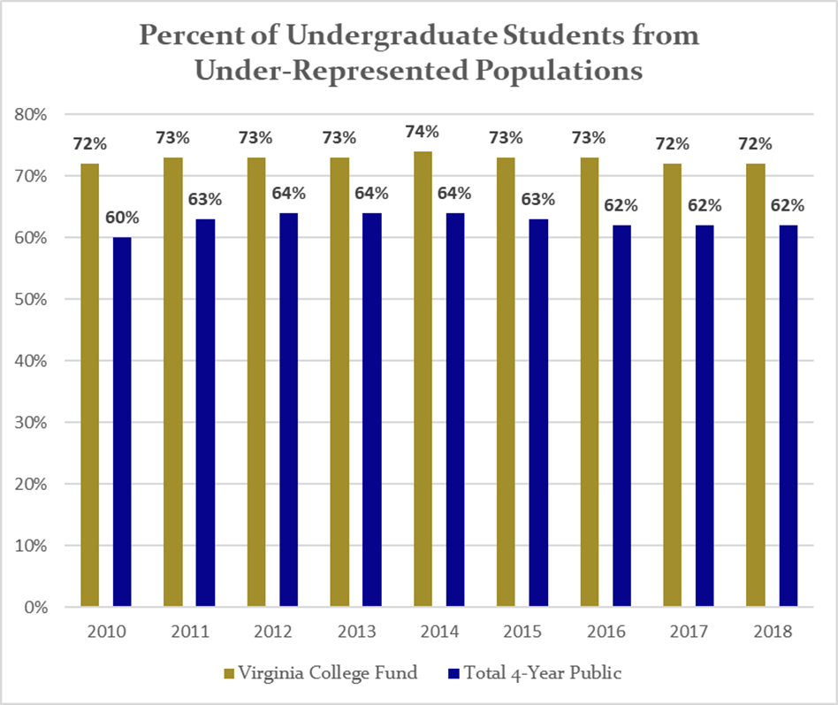
Source: State Council for Higher Education in Virginia

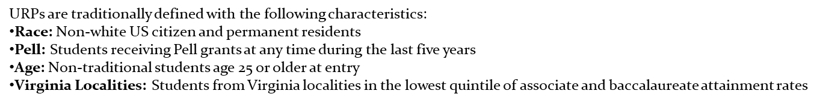

Graph 2

Source: SCHEV E22 Trends in Race Ethnicity Report

Graph 3
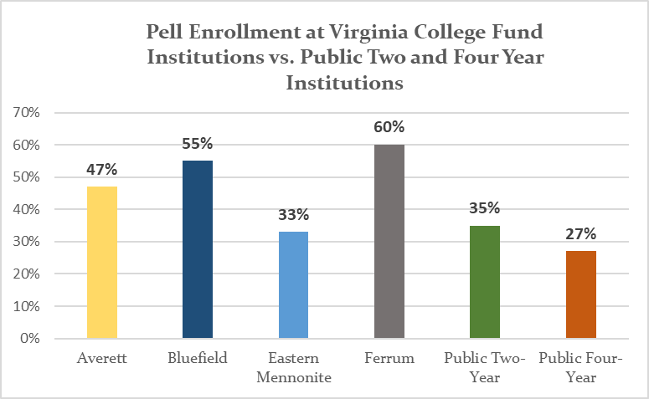
Source: SCHEV FA09 Pell Grant Report (2018-19)
Observations, Analysis, and Conclusions

2016 Strategic Plan Review

The 2016 strategic plan set out to answer whether the CARC was still relevant and sustainable. Contribution totals were continuing to decline (by 13% since 2012) continuing a longer-term trend. One factor was a reliance on one trust that decreased significantly its annual support, but other factors such as competition and messaging also contributed.

The general consensus was that the CARC remained relevant providing visibility, contacts, and financial resources to each member. And yet the fundraising had to improve. As a membership organization, the institutions pay an annual levy to cover administration costs. The institution presidents want a reasonable Return on Investment that was running a 2.7 to 1 ratio. They agreed that a 4 to 1 ratio is acceptable. The approved strategic plan established a goal to reach $1 million in contributions annually by 2020.

Table 1 below shows the CARC’s financial trends since the 2016 plan’s adoption. Contributions have continued declining by 15% since FYE 2017 through 2020. The ROI for the most recent fiscal year (2020) is 2.34 for every dollar the colleges invest.

Table 1
 |  |  |  | FY 2017 |  | FY 2018 |  | FY 2019 ⁽²⁾ |  |  | FY 2020 |  |  | FY 2021 |  |  | FY 2021
 |  |  |  | Audited |  | Audited |  | Audited |  |  | Audited |  |  | Budgeted |  |  | 10 months
 | Income
 | Contributions |  |  | $671,378 |  | $553,691 |  | $535,076 |  |  | $569,878 |  |  | $650,000 |  |  | $289,674
 | One-time Contribution ⁽¹⁾ |  |  |  |  | $2,700,000
 | Membership Assessments |  |  | $255,959 |  | $252,683 |  | $252,381 |  |  | $266,892 |  |  | $220,110 |  |  | $120,196
 | Interest/Other |  |  | $437 |  | $618 |  | $2,208 |  |  | $2,467 |  |  |  |  |  | $110
 | $50,000 carryover allotment
 | Total Income |  |  | $927,774 |  | $3,506,992 |  | $789,665 |  |  | $839,237 |  |  | $870,110 |  |  | $409,980
 | Expenses
 | Membership distribution |  |  | $666,815 |  | $554,309 |  | $586,928 |  |  | $624,525 |  |  | $650,000
 | One-time Distribution ⁽¹⁾ |  |  |  |  | $2,700,000
 | Personnel |  |  | $198,051 |  | $198,743 |  |  |  |  |  |  |  | $160,148 |  |  | $116,552
 | Management and General |  |  | $27,654 |  | $22,841 |  | $72,989 |  |  | $74,283 |  |  | $34,962 |  |  | $33,913
 | Fundraising |  |  | $37,768 |  | $30,434 |  | $122,335 |  |  | $123,578 |  |  | $25,000 |  |  | $9,965
 | Additional expense funding
 | Total Expenses |  |  | $930,288 |  | $3,506,327 |  | $782,252 |  |  | $822,386 |  |  | $870,110 |  |  | $160,430
 | Net Income/Loss |  |  | -$2,514 |  | $665 |  | $7,413 |  |  | $16,851 |  |  | $0 |  |  | $249,550
 | ROI (assessment to distribution) |  |  | 2.61 |  | 2.19 |  | 2.33 |  |  | 2.34 |  |  | 2.95
Total Contributions |  |  |  |  | 149 |  | 137 |  |  | 124 |  |  |  |  |  | 77
Average Contribution |  |  |  |  | $3,716 |  | $3,906 |  |  | $4,596 |  |  |  |  |  | $3,762
 |  | ⁽¹⁾ One-time contribution from the Guy E. Beatty Trust.
⁽²⁾ Starting in 2019 Personnel Expenses are being distributed by the auditor across the two functional areas

While contributions did not meet the plan’s goals, other positive steps were, and continue to be, completed strengthening the case for support and infrastructure. For instance:

- a marketing committee had been created in 2017 proposing an updated CARC’s mission statement and reaffirmation of its vision to and approved by the board;

- the website has been redesigned and with a new hosting service;

- an improved cloud-based donor/contact database (Little Green Light) was purchased and implemented;

- the offices were moved to downtown Richmond providing more convenient accessibility to and for donors/prospects and Commonwealth of Virginia officials; and

- most recently, a part-time grant-writer has been hired.

Notably, the most significant change since that plan was approved is the hiring of Mr. Currin in October 2020 as the CARC’s new president. Having served on CARC’s board of directors for 18 years—two as its chair—Mr. Currin possesses a deep passion for CARC’s mission and its success. Additionally, Mr. Currin’s skillset—honed by his time at the Tobacco Commission and as economic development director roles for two municipalities—is one of a sales-mentality, among other attributes, that is needed for successful fundraising.

General Interview Responses and Analysis:

Please refer to the ten individuals interviewed and the questionnaire found on Attachments 1 and 2, respectfully. Noted is of the ten, one is a member college president, four are board directors, two are Virginia higher educational association CEOs, and three are current or former funders. Eight of the interviews took place via a Zoom video call with two via a phone call. All were assured strict confidentiality, that their responses would not be attributed to them, though particular uncited responses may be used to help in this report.

- Of those interviewed, seven indicated they know the CARC very well with three moderately well.

- All (100%) agree with the CARC’s mission.

“Hearing the mission statement read, that’s what comes across and it’s aspirational.”
“In context of it supporting the four institutions and their missions”

- The colleges and their respective presidents are generally perceived as the CARC’s greatest asset.
“The passions of the presidents of the four institutions and the students each serves in the rural communities.”

- Conversely, the CARC’s greatest challenge going forward focuses on the competitive fundraising market place and the need for a clear message soliciting contributions.
“Lack of clarity for the reason seeking funds. It’s a crowded marketplace.”

Refer to the next section for additional comments and observations.

- Seven believe the CARC continues to add value to the six members, two did not, one did not know.
“Not just through the monetary purpose, but also through the conversations from and for the four institutions that are marketplace oriented.”
“The jury is out for me.”

- Eight believe the commonwealth benefits from the CARC’s efforts, two did not know.

“A lot of small colleges are disappearing. These four have found a niche to serve in an area the state needs.”

- Eight believe the CARC should invite other compatible institutions into its membership, two did not know.
That will raise VCF’s [now CARC] profile significantly and in the long run will benefit the current members.”

“They will need to have the same ‘flavor’. Don’t ask them just to have more names.”

“Hard call to make. There will be more demand for funds and it will probably spread itself too thin.”

- Six believe the CARC is being led by an effective CEO and board of directors, four did not know.
“I think the board is very talented. Carthan seems very capable. I have no reason to believe he won’t do what is expected of him.”

“It’s early on in Carthan’s tenure, but so far yes. For the board, ongoing board development is an issue. Carthan will need a more engaged board to make significant headway.”

- On a scale of one through ten, one being the worst and ten being the best, the board’s leadership rating scored a 6.6 average, ranging from a “5” to a “9”.
“5, I see some of the newer board members getting engaged, asking good questions.”

“7 or 8, the board has a very good makeup, very diverse.”

“7, but Carthan will need a more engaged board to make significant headway.”

Marketing and Differentiators:

The 2017 ad hoc marketing committee updated CARC’s mission statement and also spurred creating a marketing brochure and revising its website. Unknown are the efforts undertaken to reach new constituencies including donor prospects. While the CARC is held in high regard, that goodwill is limited primarily to those who have been long associated with the organization. The interview responses and other anecdotal observations suggest that the CARC has lacked clarity in its messaging and that even its name is confusing. Specifically,

- As stated, the CARC is highly regarded providing a valuable service to its member institutions and the Commonwealth of Virginia.

- The CARC maintains an admired reputation for the work it does on behalf of the colleges and for its stewardship.
“It’s the only thing going for these four institutions (statewide) with its unique mission.”

- The CARC’s greatest challenge is a lack of awareness and the reasons it is seeking funds. Interview comments include:

“Clarity of (others) understanding its mission and how it complements the schools’ resources.”

“To get better known, to get people without a direct relationship with the schools to understand their value.”

“The challenge is the colleges defining themselves. They seem to be a cross between traditional liberal arts and community colleges emphasizing workforce development.”

- On behalf of the member colleges, the CARC presents a compelling case for support. “Minority”, “low-income”, “1st generation”, “rural”, “underserved” all appeal to individuals and funders desiring to raise up the commonwealth and its citizens through education. However, these terms have been loosely bantered about without quantifying what they mean and how they are being addressed. Funders want to see the results of their investment.

- However, the CARC, along with its member colleges, must contend with, in addition to higher education competition in general, the commonwealth’s community college system specifically. The commonwealth had previously implemented a guaranteed admission program to its public four-year colleges if a community college student graduates with an associates degree and minimum grade point average.

Approved in the recently concluded General Assembly session is a new program known as “G3, Get Skilled, Get a Job, Give Back” that will make community college free for low- and moderate-income students seeking jobs in high demand fields such as health care, manufacturing, and technology.

Furthermore, President Joe Biden’s administration is seeking its own initiative to make a community college education free.

- Another important component in the CARC’s case for support is its members’ economic impact within the commonwealth. Collectively they employ over 1,400 people spending over $64 million on salaries, wages and benefits each year.

Each member contributes to its respective community’s culture and identity. And each contributes significant financial support to the economies and workforce. However, recent data extolling the members’ economic benefits could not be located. The most recent was reported by Bluefield College in 2011 from a Chmura Economics & Analytics study.

Opportunities:

While the CARC’s purpose is to raise funds supporting its members, opportunities of providing direct programs and scholarships for the colleges’ students and faculty can help raise its profile. Additionally, these initiatives could appeal to a wider pool of donor prospects to fund while also making contributions on the general fund for the colleges.

For comparison purposes, the Virginia Foundation for Independent Colleges, while representing a different membership constituency, offers to its members eight separate program opportunities and five scholarship opportunities.

One of VFIC’s better known programs is the annual Ethics Bowl described on its website as

Distinguished professionals serving as judges and moderators, faculty members, and students from across Virginia support the VFIC’s annual Ethics Bowl testifying to the priority that each of these individuals places on personal ethics in the workplace, classroom, and all aspects of their lives.

Current CARC board member Brad Hall also serves on the VFIC board. He indicated he would be willing to help facilitate an Ethics Bowl competition between the two organizations

One recent initiative Mr. Currin has undertaken for CARC is a scholarship in the name of the late Ms. Betty Jolly. A committee has been formed to determine the specifics of recipient criteria and award amount(s).

Development and Fundraising:

According to the Council for Advancement and Support of Education in a February 2021 report, higher education fundraising nationally was down only slightly as of June 2020 despite the country being in the throes of the Covid-19 pandemic and resulting economic lockdowns.
($49.5 billion v $49.6 billion). Graph 5 below shows the sources of the 2020 donations.

Graph 5
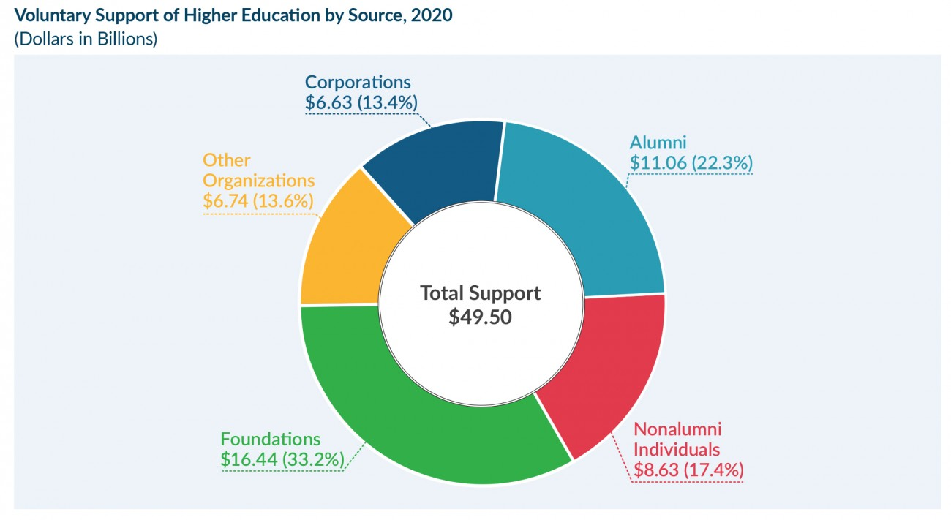
Source: Council for Advancement and Support of Education (CASE)

Even with the pandemic, however, what has sustained, perhaps better than expected, philanthropic giving to all organizations has been Wall Street’s market rebound and growth. According to The Washington Post, “The U.S. stock market ended 2020 at all-time highs.”. The S&P 500 was up 15.76%, the Dow Jones industrial up 7.25%, and the NASDAQ up 43.6%. The Post continues the impetus of the growth was “…fueled by the largest federal government stimulus ever, historic support from the Federal Reserve and optimism about how quickly the economy is likely to bounce back next year…”

However, anecdotal evidence suggests higher education giving will further decrease in 2021 and into 2022 as contributions were and will be directed to human service organizations.

As reported in Inside Higher Ed, “In fiscal 2021, the (fundraising revenue) declines are projected to be even steeper (than 2020). Nearly 45 percent of institutions (of 110 survey respondents) project double-digit declines in fundraising revenue, and a growing number of colleges project a decline of 30 percent or more compared to 2019 totals.”

Accordingly, interviewees for this strategic plan generally acknowledged the CARC is in a difficult fundraising environment.

(A challenge is) “four small colleges competing for unrestricted giving, which is very difficult as is.”

(It is a) “tough environment.”

Of note is the Giving USA annual report of philanthropic giving and analysis, showing the trends and detailed data for 2020 philanthropy, that will be released in June 2021.

Strengths, Weaknesses, Threats, and Opportunities

Strengths

- CARC provides visibility and access to donors, prospects, and the public that may not otherwise occur for its members individually.
- The six colleges and their presidents are predominantly regarded as exceptional and succeeding with an underserved demographic in the commonwealth.
- An engaging and committed board of directors.
- A new and well-connected, impassioned, and enterprising chief executive officer.
- CARC benefits from a worthy and unique mission with an established admirable reputation built over the years.
- The contributions received support its members’ operations and students directly versus restricted to support specific areas such as a program or sports, helping moderate tuition increases.
- Recent improving infrastructure in staffing and database management.
Weaknesses

- CARC’s contributions have continued declining the last four years, decreasing 15% since 2016.
- Consequently, the member institutions’ return on investment correspondingly decreased.
- CARC’s name creates confusion in the general public.
- Lack of awareness in the commonwealth.
- Limited budget and staffing to allow the CEO unfettered time meeting with donors and prospects, and for the organization to implement its own programs.
- Lack of economic benefit data members provide their respective communities.
- Lack of an endowment to ease the members’ financial burden funding operations.

Threats

- Student enrollment competition will continue to increase as the Commonwealth of Virginia expands its community college initiatives, previously providing automatic entrance to four-year public institutions, to provide “free” tuition, et. al. for low- and middle-income Virginians (G3 Program). This initiative could affect CARC by diluting its case of support claiming its members’ high reach into that and first-generation demographics.
- An already competitive fundraising marketplace exacerbated by the Covid-19 pandemic.
Opportunities

- The hiring of a new president providing a renewed passion and commitment.
- There are several compatible four-year colleges/ universities in the commonwealth that could expand and complement CARC’s reach and case for support if made members.
- Collaborative opportunities with the Virginia Foundation of Independent Colleges.
- Creating its own programs and special events, particularly focused on the members’ students.
- The country and the commonwealth are at the cusp emerging from pandemic and resulting economic lockdowns.

Recommendations, Goals, and Timeline

The Commonwealth Alliance for Rural Colleges is positioned to undertake bold and pivotal change to meet the fundraising and operational challenges it will continue to face if the status quo is allowed. New leadership and a reestablished commitment of the board of directors provide momentum for the CARC to flourish in supporting its member institutions. For each—and collectively—provides a vital education alternative within the commonwealth’s vast fabric of higher education options to those underrepresented – minorities, low- and moderate-income families, and first-generation students. Additionally, each institution, being located in rural communities removed from robust economic development efforts, provides those communities significant financial resources and sources of pride.

The following recommendations are suggested to ensure the CARC becomes a dominant financial contributor to its members while indirectly adding value to the Commonwealth of Virginia.

- Recommit to a fundraising goal meeting a 4 to 1 Return on Investment to the member institutions.

Adopt a five-year plan that incrementally increases contributions at a reasonable rate. However, in order to achieve these goals additional staff and resources will need to be committed requiring additional operational funding, anticipated being an annual $50,000 need.

There are several options to fund this additional expense. One option, in addition to other beneficial reasons addressed in Recommendation 3 below, would be to invite additional members. According to the CARC’s bylaws, a new member’s assessment following its first full year will incrementally increase 20% of budgeted expenses each year reaching 100%after the fifth full year. Calculating current expense needs of $320,000 going forward will provide the additional $64,000 from the new member.

However, unless the bylaws are modified, those first five years will have to be covered by current members. Perhaps the members can maintain the annual membership assessment constant at $250,000 but reducing the annual distribution for each year by $50,000 the first two years and incrementally decreasing as the new member(s) assessment is increased.

The board of directors agreed the current environment is ideal to review the by-laws, member assessments, member allocations, and new members. An ad hoc committee will be formed, chaired by Mr. Lee Osborne, populated by the four presidents among others, and report back to the board with recommendations at the June 2021 annual meeting.

The pro forma in Recommendation 5 (Table 2) shows that assessment trend. Additionally, in Table 2 incremental contributions increase by 20% annually in addition to other assumptions to reach $1,244,160 by fiscal year-end 2026 resulting in a 3.67 ROI.

Noted is this plan generates very aggressive fundraising goals. For instance, next year’s (FY 2022) goal of $600,000 is a $250,000 increase from what is expected for this year ($350,000). Some will likely opine these goals are not achievable. However, with CARC having the right people in place and the renewed commitment from the board, the prospect of success has never been better. And in the final analysis, the college presidents must see demonstrable and aggressive progress to continue justifying their investments.

- Change the name to better reflect the CARC’s mission.

The consensus of those interviewed in addition to anecdotal comments, the name “Commonwealth Alliance for Rural Colleges” evokes confusion to those unaware of the organization.

- Form an ad hoc committee to further study the CARC’s name with the goal of changing it to better reflect its mission and the student population it represents. Consideration should also be given to a new logo and rebranding. A marketing agency should be considered to assist with this task.

- Once complete and approved by the board of directors, create a public relations event announcing the change and rebrand.

- Follow the announcement with a wider public relations initiative sending a press release to select media throughout the commonwealth.

- Consider purchasing advertising for the announcement in such publications as Virginia Business, Virginia Living Magazine, The Roanoker Magazine, and local newspapers.

These announcement recommendations are to jump start an awareness campaign that should make it easier to approach those unaware of CARC. If a donor prospect is already aware, any CARC representative should not have to spend 15 minutes explaining the “3Ws” – who, what, why. Continue with selected public relations stories and milestones as appropriate.

- Invite additional institutions for membership.

A handful of like-minded institutions catering to the same student demographic as the CARC’s existing members exist should be considered to invite to CARC membership.

Conceivable candidates, with their respective mission statement, are listed below. Generally, each is private attracting and enrolling a smaller student body, and each is located in a rural, underserved community within the commonwealth.

- Appalachian College of Pharmacy, Oakwood, (225 students),

“provides academic, scientific, and professional pharmacy education to address the health-related needs of rural and under-served communities, particularly those in Appalachia, through education, service, and scholarship.”

- Patrick Henry College, Purcellville (344 students), and

“to prepare Christian men and women who will lead our nation and shape our culture with timeless biblical values and fidelity to the spirit of the American founding.”

- Southern Virginia University, Buena Vista (1,100 students).

“to gather faithful Latter-day Saints and like-minded students, lift them in intellect, character, and spirituality, and launch them into successful lives and careers.”

The benefits of expanding membership include:

  - Further fulfilling CARC’s own mission representing a larger constituency with a large portion of their student bodies coming from underserved families who may not otherwise seek a post-secondary school education.

  - With a larger membership, CARC will presumably gain access to additional donor prospects. There will not only be those who represent those institutions, but also there will be those, such as foundations, who recognize the increased value their contributions provide to a larger base of beneficiaries.

  - Provide additional assessment revenue to expand staff needed to successfully raise additional funds meeting the 4 to 1 ROI goal.

A short-term consideration is the risk of distribution dilution to current members though each should reap the longer-term benefit as CARC scales up reaching more donors and with a more concise case for support.

CARC’s bylaws state any new member to receive an increasingly incremental distribution over five years starting with 20% after its first year, sharing 100% equally in year six. Correspondingly, any new member’s membership assessment is prorated over the same six-year period.

The tiered arrangement should mitigate near-term dilution while giving the organization ample time to fully leverage the new member’s association.

- Consider initiating unique programs

The CARC can aid each member while also raising its own profile by hosting programs and scholarships focused on member students and/or faculty. Already underway is the creation of the Elizabeth “Betty” Jolly Scholarship with an ad hoc committee analyzing its structure, process, and funding expectations.

Ms. Jolly, who passed away in 2017, “worked in public service in higher education as government liaison director for three Virginia universities and was an appointee in the administrations of two governors” as noted in her obituary. She was also a long-time CARC board member and influencer raising the CARC’s profile throughout the commonwealth.

A preliminary goal is to raise $100,000 to fund the scholarship.

This scholarship is but one example that the CARC can undertake to simultaneously fulfill its mission supporting its members and raising its public profile.

An immediate program the CARC can pursue is in partnership with VFIC in its annual Ethics Bowl. As earlier noted, current CARC board member Brad Hall also serves on the VFIC board. He indicated he would be willing to help facilitate an Ethics Bowl competition between the two organizations.

One idea is each would run its own member competition resulting in a runoff taking place between those two winners.

Another program idea is to create a student writing competition with perhaps a cash award or scholarship. One subject that would differentiate the CARC from similar competitions is civics and American history that lacks in our education system. As noted by six former U. S. secretaries of education in a recent Wall Street Journal od-ed:

Regrettably, civics, which reaches skill of participation and the knowledge that sustains it, and history, which provides a frame of reference for the present, have been sorely neglected over the past half-century in U.S. schools.

They are supporting a national effort, the Roadmap to Education for American Democracy, with whom the CARC may be able to collaborate if it undertakes such an initiative.

- Adhere to a recommended development plan, to be updated and modified as needed

As noted, raising significant funds is difficult without a clear case for support and the lack of resources needed to successfully follow the donor cycle of identifying, cultivating, soliciting, and stewarding individuals, foundations, and corporations. The Covid-19 pandemic has exponentially increased that difficulty.

The following components create a foundation of a development plan that will need to be refined by staff and implemented with both staff and the board of directors.

When we ask for money, we are friends, not adversaries. We are counselors, not salesmen. It’s not a game of predator and prey. We are trying to help the donor do something significant for the community and for society. James Gregory Lord

- Setting the fundraising pace begins at the top and every board member should make a meaningful, personal contribution.

Staff should create a realistic annual goal for the board of directors who are then solicited by the board chair or other board leadership.

- Additionally, board members must be actively engaged in the donor cycle raising funds. They must introduce friends and colleagues to the CARC, help cultivate those individuals making the case for support, and help make the ask of major donors (in this case defined as having the capacity to contribute $2,500 and above annually).

- Convene six donor/prospect breakfasts or lunches annually hosted by one or two board members in their respective community. Meeting for no more than an hour, these gatherings are an excellent way to introduce prospects to the CARCand update current donors. Mr. Currin could expand his Northern Virginia Roundtable initiative to create a roundtable in each of the commonwealth’s “Go Virginia’s” nine regions.

Invite representative member students and alumni/ae to these functions (as well as other events like the annual luncheon) to tell their story. They are the reason to support the CARC.

The goal is to have 5 to 12 “outsiders” attend each event.

- Make the current grant writer/development associate position full-time and expand that position’s responsibilities to include managing the Little Green Light database; assisting with mail appeals and thank you letters; assist with cultivation/stewardship event, and other programs if implemented, logistics; and reporting.

Mr. Currin needs the office help so that he can meet with donors and prospects throughout the commonwealth.

Recommend a goal of four private/corporate foundation grant requests be written monthly.

- Quantify the CARC’s case for support with the data provided by the State Council of Higher Education for Virginia and the Council of Independent Colleges in Virginia. Show how the CARC is succeeding educating the “under-represented population” and otherwise making a difference in Virginia.

- Engage past board members in helping with the donor cycle. They are another constituency to invite to the monthly functions, and they are probable cohosts.

- Donor and prospect files, both paper and electronic, need to be created and utilized. A written profile should be created for major donors/prospects (suggest those capable making contributions $25,000 and above).

- The president should send thank you/acknowledgement letters to each donor no more than a week after the contribution is made. For those contributions above $2,500 in which a board member helped cultivate and/or solicit, that board member should also send a note or sign the thank you/acknowledgement letter.

- Enhance the case for support by engaging a economic data analytics firm such as Chmura Economics & Analytics or the Weldon Cooper Center for Public Service to ascertain each member’s economic benefits.

- Create an annual report to be sent to the entire constituency by the end of August each year.

- Send two general appeal letters to donors/prospects generally determined to contribute less than $1,000, once in November and once in May each year.

- Mr. Currin should attempt to meet with or call five major gift donors/prospects weekly.

- Refer to the below pro forma Table 2. Using the 2021 budget of $650,000 as the base and applying a 20% annual contribution increase will reach a 3.67 to 1 ROI in FY2026. Other assumptions are noted below.
Table 2
 | FY 2021 | FY 2021 | FY 2022 | FY 2023 | FY 2024 | FY 2025 | FY 2026
 | Budgeted | 10 months | Pro Forma | Pro Forma | Pro Forma | Pro Forma | Pro Forma
Income
Contributions | $650,000 | $289,674 | $600,000 | $720,000 | $864,000 | $1,036,800 | $1,244,160
Membership Assessments | $220,110 | $120,196 | $270,000 | $320,000 | $320,000 | $320,000 | $320,000
Interest/Other | $0 | $110 | $2,500 | $2,500 | $3,000 | $3,000 | $3,500
$50,000 carryover allotment |  |  | $50,000
Total Income | $870,110 | $409,980 | $922,500 | $1,042,500 | $1,187,000 | $1,359,800 | $1,567,660
Expenses
Membership distribution | $650,000 |  | $654,375 | $781,875 | $890,250 | $1,019,850 | $1,175,745
Personnel | $160,148 | $116,552
Management and General | $34,962 | $33,913 | $83,025 | $93,825 | $106,830 | $122,382 | $141,089
Fundraising | $25,000 | $9,965 | $147,600 | $166,800 | $189,920 | $217,568 | $250,826
Additional expense funding
Total Expenses | $870,110 | $160,430 | $885,000 | $1,042,500 | $1,187,000 | $1,359,800 | $1,567,660
Net Income/Loss | $0 | $249,550 | $37,500 | $0 | $0 | $0 | $0
ROI (assessment to distribution) | 2.95 |  | 2.42 | 2.44 | 2.78 | 3.19 | 3.67
Total Contributions |  | 77
Average Contribution |  | $3,762
⁽²⁾ Starting in 2019 Personnel Expenses are being distributed by the auditor across the two functional areas
Pro Forma assumptions: Historically, expenses have run as a percentage of total revenue: Distributions (75%),
M&G (9%) and fundraising (25%). For FY 2022 the $50,000 assessment funds additional staffing and resources.

- Below is a comprehensive Action Timeline

Action | Completion Date | Responsibility | Remarks
Thank you letter to outsider interview participants | 4/15/2021 | President | include report as appropriate
By-law’s review/recommendation | June Annual meeting | Lee Osborne/Ad hoc committee | Financial support, member assessments/ allocations, new members
Annual donor/prospect luncheon | June 2021 | President/staff | selected venue
Secure board member commitments | July 2021 | President/board chair
Betty Jolly Scholarship established | August 2021 | President/committee | $100,000 goal, able to receive applications
Donor/Prospect breakfast/lunch | August 2021 | President/selected board member(s) | venue in selected community hosted by board member
Annual Report sent | August 2021 | President/staff | sent to all constituencies
Donor/Prospect breakfast/lunch | September 2021 | President/selected board member(s) | venue in selected community hosted by board member, goal is 5 - 12 donors and/or prospects
Donor/Prospect breakfast/lunch | October 2021 | President/selected board member(s) | venue in selected community hosted by board member, goal is 5 - 12 donors and/or prospects
Donor/Prospect breakfast/lunch | November 2021 | President/selected board member(s) | venue in selected community hosted by board member, goal is 5 - 12 donors and/or prospects
Year-end appeal | November 2021 | President/staff | recipients generally previous donors and prospects below $1,000 level
Donor/Prospect breakfast/lunch | February 2022 | President/selected board member(s) | venue in selected community hosted by board member, goal is 5 - 12 donors and/or prospects
Donor/Prospect breakfast/lunch | March 2022 | President/selected board member(s) | venue in selected community hosted by board member, goal is 5 - 12 donors and/or prospects
Donor/Prospect breakfast/lunch | April 2022 | President/selected board member(s) | venue in selected community hosted by board member, goal is 5 - 12 donors and/or prospects
General appeal letter | May 2022 | President/staff | recipients generally previous donors and prospects below $1,000 level
Refine FY2023 development plan | May 2022 | President/staff | affirm goal, strategy, and tactics
Individual donor/prospect meetings and calls | ongoing | President | goal is five a week; focus is following up with those attending previous events, and also others as selected
Private and corporate foundation grant requests | ongoing | grant writer/president | goal of four a month
Thank you/acknowledgement letters | ongoing | admin/president | sent NLT week following gift receipt
Strategic plan review | quarterly | Board/president | Standing agenda item
Donor/Prospect breakfast/lunch | continuing | President/selected board member(s)

As approved:
- New member invitations and on-boarding
- Name change and rebrand announcement and public relations initiatives

- Lay the groundwork to allow endowment contributions

Don’t actively solicit until the annual giving reaches $1 million. However, there could be opportunities from individuals desiring to make a bequest or other planned giving instrument funding the endowment.

The board may consider transferring any net revenue at the end of a fiscal year to the endowment fund. These funds are considered “board designated” and can be used in the future should circumstances dictate, unlike “donor restricted” contributions to an endowment.

Attachment 1 – Interview Participants

Mr. Peter Blake
Director
State Council of Higher Education
in Virginia

The Honorable Richard S. Bray
President and CEO
Beazley Foundation, Inc.

Mr. Brad N. Hall *
Vice President, External Affairs
Appalachian Power Company

Dr. David L. Johns, Ph.D. *
President
Ferrum College

Mr. Robert Lambeth
President
The Council of Independent Colleges
Mr. Richard W. Loving *
Senior Vice President - HR
BWX Technologies, Inc.

Ms. Elizabeth G. Povar, CEcD *
Principal Officer
The RiverLink Group

Mr. Harvard Smith
Chair
Universal Leaf Foundation

Ms. Ellen Spong
SVP and Director of Institutional
Advisory Group
Atlantic Union Bank

Ms. Judith R. Trumbo *
President and CEO
Virginia Mennonite Retirement Community

* Denotes current CARC board member

Attachment 2 – Interview Questionnaire

- What is your relationship with the Commonwealth Alliance for Rural Colleges?
(Donor, volunteer, member institution, or general awareness, etc.)

How well would you say you know the VCF?
(Very, Moderately, Heard of it, Not at all)

- Please describe your understanding of the CARC’s mission or purpose.

- Do you agree with that mission/purpose? (yes, no) Comments:

- If you know the CARC, what do you believe is its greatest asset?

- Conversely, what do you believe is its greatest challenge/problem going forward?

- Do you believe the CARC continues to add value to its six member institutions? (yes, no) Comments:

- Do you believe the Commonwealth of Virginia benefits from the CARC’s efforts on behalf of the six institutions? (yes, no) Comment:

- What in the past has prevented or now might prevent CARC from reaching its fundraising goals?

- What external variables should CARC be concerned about as it solicits contributions?

- What is most important for CARC to express marketing itself to its donor and prospect constituencies?

- Do you believe the CARC should consider changing its name to better reflect its mission and for marketing? (yes, no) Comment:

- Do you believe the CARC should invite other compatible, non-VFIC institutions into its membership? (yes, no) Comment:

- Do you believe that the CARC is being led by an effective and engaging CEO and board of directors? (yes, no) Comment?

- On a scale of one through ten, one being the worst and ten being the best, how would you rate the board’s leadership?

- What happens if The CARC were to go out of business? Why would it matter? To whom would it matter?

- Is there anything else you would like the CARC to know or consider that hasn’t been already covered?

Interview response word cloud
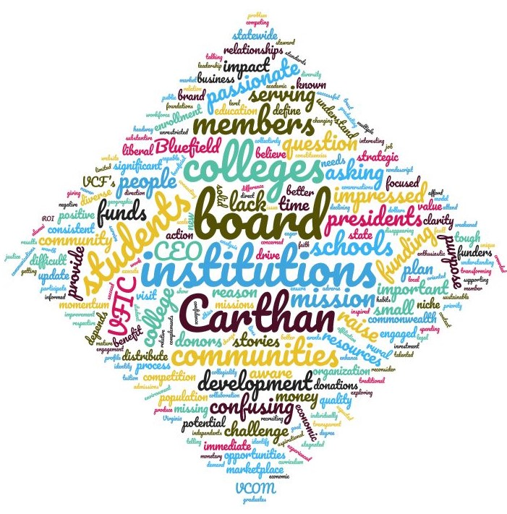

Attachment 3 – Bibliography and References

Alexander, Lamer, et. al., “America Needs History and Civics Education to Promote Unity.” Wall Street Journal, March 3, 2021

American Council on Education, “Key Issues Facing Higher Education Philanthropy”, Washington, D.C., 2019. https://www.acenet.edu/Membership-Advancement/Pages/Advancement/Trends-in-Private-Giving-to-Colleges-and-Universities.aspx

Bluefield College, “BC Injects Millions into the Local Economy”; “Bluefield College in the News”, https://www.bluefield.edu/bc-injects-millions-into-local-economy, February 1, 2011

Kaplan, Ann E. “Voluntary Support of Education Key: findings from data collected for the 2019–20 academic fiscal year for U.S. higher education institutions”, Council for Advancement and Support of Education, February 2021

Leonor, Mel. “Free Community College Plan Nears the Finish Line.” Richmond Times-Dispatch, February 16, 2021

Moretz, Sabena, et. al. “Briefing Materials” PowerPoint, Council of Independent Colleges in Virginia, November 2020

Shaban, Hamza and Long, Heather, “The stock market is ending 2020 at record highs, even as the virus surges and millions go hungry”, The Washington Post, December 31, 2020

State Council of Higher Education for Virginia. https://research.schev.edu/info/Reports/Guide-to-the-Enrollment---Annual-FTE-Reports

The Commonwealth Alliance for Rural Colleges Website: www.commonwealthalliance.org

Virginia Foundation for Independent Colleges website: www.vfic.org

West Avenue Associates, “Strategic Planning Presentation and Recommendations”, PowerPoint, September 29, 2016 and “Strategic Plan Update” Report, September 13, 2017

Whitford , Emma. “Survey Warns of ‘Dramatic Decline’ in Fundraising”, Inside Higher Ed, June 8, 2020. https://www.insidehighered.com/news/2020/06/08/survey-forecasts-%E2%80%98dramatic-decline%E2%80%99-fundraising-pandemic

